How to read a metric vernier calliper
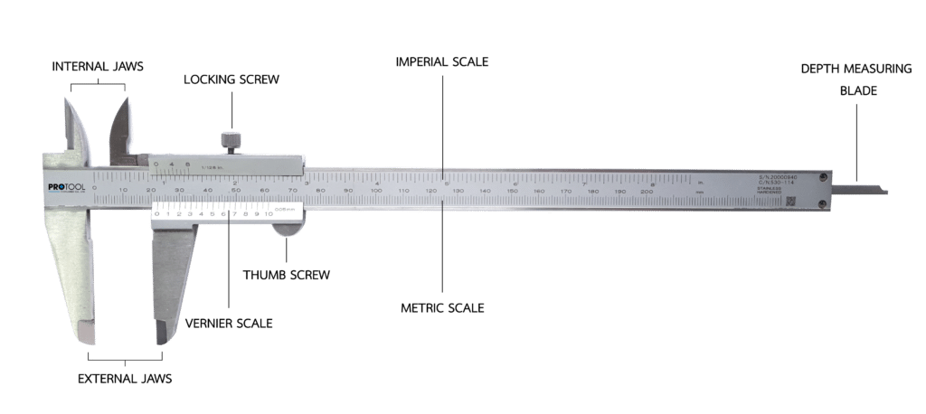
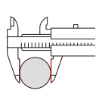Measure the outside dimensions
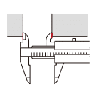measure the inner size
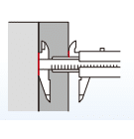measure different portion sizes
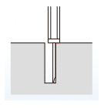measure the depth
A Vernier Calliper is a precision instrument can be used to accurately measure internal and external distances, and depths. The example shown below is an analogue vernier where measurements need to be interpreted from a scale. This type of vernier is more difficult than a digital vernier calliper with a readable digital display but once mastered gives far more reliable and actionable readings. Models used should read both imperial (inches), metric (mm) sizes.

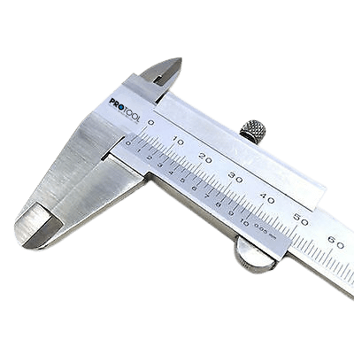
STEP 1 Check Vernier before use.
Check the vernier calliper is working by closing the Vernier Calliper jaws. Check for damage of temple mouth of the Vernier by holding it up to a light. If the light emanates The Vernier’s mouth, the jaws are damaged and an accurate reading cannot be obtained.

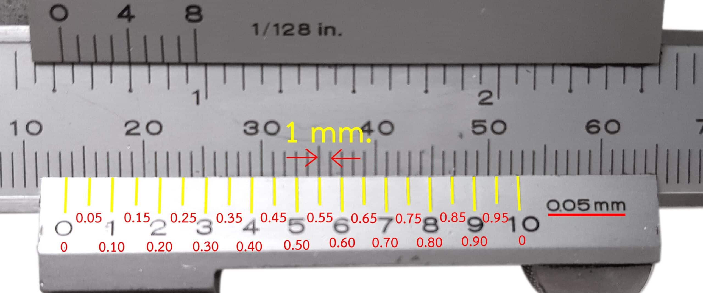
STEP 2 Look at the main scale.
The vernier has twenty spaces between 0-20 on the Vernier scale. These small divisions of main scale, mark increments of five hundredths of millimeter (0.05 mm).
The main scale reads in millimetre increments.

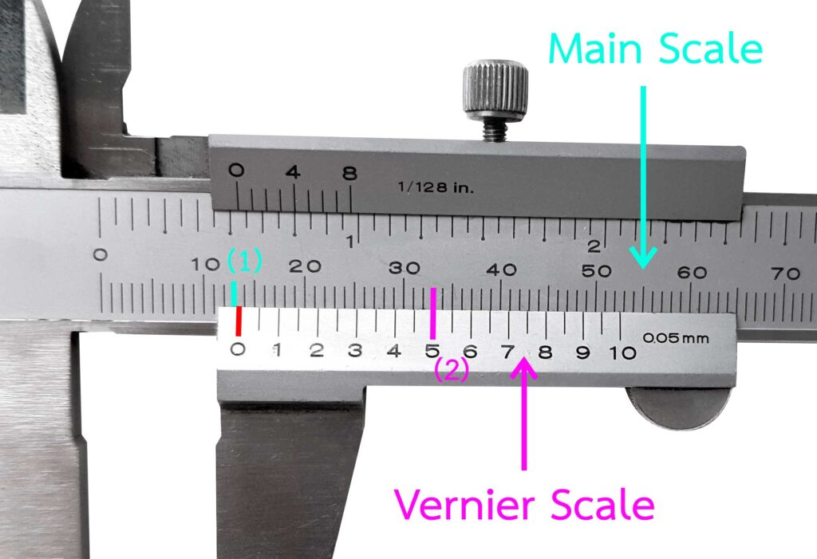
STEP 3 How to read a metric vernier caliper
Graduation 0.05 mm.
(1) Main Scale 13 mm.
(2) Vernier Scale 0.50 mm.
Reading 13.50 mm.
Read the measurement result at the Main scale.
Note the bottom center “0” of the Vernier scale corresponds to the range of the main scale above it. In the figure, you can see the bottom center scale relative to the top scale of the top button in the range 13 mm to 14 m. m can be read at 13.00 mm. in the main scale
Read the measurement result on the Vernier scale.
Note the scale position at the bottom of the Vernier and assess which graduation aligns with any Main-scale-graduation. From the figure it can be seen that 10th vernier scale, the lower line corresponds to the main scale above.
Multiplying the bottom scale line of vernier scale read is 10 scale x 0.05 mm resolution equals 0.50 mm. Measurement result to main scale + measure result read from the vernier scale is 13.00 mm + 0.50 mm equals 13.50 mm.

